OFFICIAL COORDINATION REQUEST FOR
NON-ROUTINE OPERATIONS AND MAINTENANCE

COORDINATION DATE- 31 August 2011 updated 25 October 2011
PROJECT- Bonneville Lock and Dam
RESPONSE DATE- 1 November 2011 (FPOM meeting)

Description of the problem- (previously coordinated bathymetry work was completed in mid- October).

Due to the changes in the ladder availability at BON, an updated MOC seemed warranted. In addition, the Project found some potential erosion they would like to investigate further. Please review and if you have comments opposing this action, please get those to me as soon as you can. Right now the Project is planning the dive with the additional ROV work for next week.

There will also be a dive inspection of the apron undercut at the north end for bays 2-4 and an ogee inspection at bays 9, 12, and 14. This dive is scheduled for 2-4 November.

In addition, a ROV inspection of the riprap downstream of the Cascades Island (CI) fishway entrance is needed due to recent discovery of potential erosion (found during the bathymetry survey).

Type of outage required- For the apron undercut dive- Bays 1-17 will need to be on sill (Bay 18 remaining closed) for four hours.

For the ogee dive- Bays 2-17 on sill, with bay 1 left at 6”.

In addition, a ROV inspection of the riprap downstream of the CI fishway entrance is needed due to recent discovery of potential erosion (found during the bathymetry survey). This work will require the attraction flow from Bay 1 to be off.

Impact on facility operation- For the dives, bays 2-17 would be on sill for eight hours and Bay 1 would be on sill for four hours. Bay 18 would remain closed.

Length of time for repairs- For the dive, Bay 1 will be closed up to four hours on 2 November and up to two hours on 3 November to accommodate an ROV inspection of the riprap downstream of the CI fishway entrance.

Expected impacts on fish passage-
Due to the emergency closure of B-Branch, there will be neither attraction flow nor passage through Bay 18 and B-Branch.

During the dive and ROV on 2-4 November, Cascades Island fishway will remain in critieria, however, attraction flow from Bay 1 will be off.

Looking at the diel passage information, there appears to be a dip in fish passage (at the count window) around 1000. The Project proposes closing Bay 1 from 1000 – 1400.

Comments from agencies
NOAA Fisheries- Fredricks’ comments from 7 September 2011.
- The MOC referring to Bonneville Dam spillway survey. This outage (now scheduled for October 3 and 4) should not overlap the early portion of the Washington Shore ladder outage (now October 1 through November) referred to in the MOC on that subject. Fish passage numbers during the first two weeks of October are typically still high at Bonneville. Scheduling this for earlier in September isn’t good either because of even high adult fish passage rates. I recommend this outage be postponed until late October or November.

----- Forwarded Message -----

From: Gary Fredricks <Gary.Fredricks@noaa.gov>
To: Tammy Mackey; "Klatte, Bernard A NWP" <Bernard.A.Klatte@usace.army.mil>
Sent: Wednesday, October 26, 2011 12:39 PM
Subject: Re: MOCs for BON: DSM 2 and spillway dive

Tammy/Bern, I think we need to pull together the FPOM to discuss Bonneville operations for best adult passage during all these outages and activities. We should NOT be operating the second powerhouse without fish ladders (and STS's) in service during the remainder of the passage season. However, from what I have heard it appears that this powerhouse has been operating up to 3 units at a time without a ladder system. The issues we need to discuss include (not in any order):

1. Unit 9 availability (is Gantry 4 on schedule) 2. P2 unit priority if a unit must run (I don't think MU18 should be first) 3. Flat loading the river (I realize this may conflict with the chum operations) 4. Spilling excess of P1 flow if necessary (once everyone is out of the tailrace) 5. Running the corner collector for adult passage once the STS's are pulled (if the powerhouse operates) 6. Increasing capacity of P1 by going to max unit flow (above best geometry)

Thanks, Gary

BON Tech Staff- -----Original Message-----

From: Perletti, Kevin P NWP
Sent: Friday, October 21, 2011 9:30 AM
To: Fox, Jessie A NWP; Benoit, Richard A NWP; Manny, D. Todd NWP
Subject: ROV of Cascade Island Underwater riprap and concrete shield

Jessie, There is a fairly urgent need to have our dive office provide ROV service to inspect subject area. This subject area is directly across the spillway stilling basin to the eroded area at B-Branch that is currently being repaired. The hydrosurveying done this week of the spillway stilling basin has detected some suspect areas (see attached) to which the ROV should be able to confirm condition.

The plan would for this to happen on Monday, 10/24. We would use Jon Thomas's clearance on the spillway on Monday morning. Bay 1 gate will need to be placed on sill prior to the clearance being hung (need fisheries coordination). Jon would walk the clearance at around 7:30 am. The Rangers (Greg Webb) will provide the ROV boat and use their standing BRZ permit to enter the spillway tailrace at around 8:00 am. Todd Manny would be the ROV service provider. The ROV work should not take more than a couple of hours. Techstaff and/or maintenance (and possibly construction, EC-CB) will have someone on the boat as well to witness.

I do not have a WOR written up for this so am not sure how funding is to be provided, specifically for the Dive office and the rangers.

Kevin

-----Original Message-----
From: Perletti, Kevin P NWP
Sent: Monday, October 24, 2011 12:59 PM
Subject: CLEARANCE REQUEST FOR SPILLWAY APRON DIVE

The navy will have divers here starting on Nov 2 and going through Nov 3 (Nov 4 is optional day) The divers and ROV will be inspecting the following:

Spillway Apron Area from Bay 1-5 (Need Bay 1 gate down on sill) Depressed area of stilling basin floor of Bay 3 Erosion Holes at Bays 9, 12, and 14 Erosion Hole at secondary basin at Bay 15 Spilling Apron Area at Bay 17-18 Erosion in riprap on Cascade Island Shore Slab/Cap area - OPTIONAL

To facilitate these dives, I request a clearance to be hung starting Nov 2 follows

Bay 2-18 Spillway Gates on Sill
Bay 1 Spillway Gate as positioned (6" above sill or on sill)

Gantry 5, Main Hoist Breaker in Cab (no. 7) OPEN Gantry 6, Main Hoist Breaker in Cab (no. 7) OPEN South Tower Spillway Hoist Power DS-1 BKR 5 OPEN North Tower Spillway Hoist Power DN-1 BKR 1 OPEN

Notes

1. We will have to close Bay 1 for diving/ROV in the area affected by that flow. Need fisheries input as to how long we can close it. I would assume we need at least 4 hours of dive (for spillway apron) with Bay 1 gate on sill. If there is a desired day and time for this during the period of Nov 2-3, we would like that input. Otherwise we will schedule it as desired.

2. OPTIONAL inspection of riprap on Cascade Island will be done by ROV only and will require Bay 1 Spillway gate on sill also. It may be feasible to do this ROV work directly before or after the apron dive work.

CRITFC- -----Original Message-----
From: Tom Lorz [mailto:lort@critfc.org]
Sent: Tuesday, October 25, 2011 3:57 PM
To: Mackey, Tammy M NWP
Subject: Re: FPOM: Official Coordination- 111031 updated 110831 BON spillway tailrace survey

Understand the need, not excited about further reducing attraction to what ladders we still have operating. Is there anyway to take the 4 hour sill operation and do this later in the day or at least start later and let the fish move through in the morning if possible.

Thanks tom

NWP Fish- -----Original Message-----
From: Mackey, Tammy M NWP
Sent: Tuesday, October 25, 2011 4:02 PM
To: 'lort@critfc.org'
Subject: Re: FPOM: Official Coordination- 111031 updated 110831 BON spillway tailrace survey

The original request was 0800 start. Rerecich and I looked at diel passage. There is a bit of a dip at 1000 for B run STHD. That seemed like a good time to start. There is an internal call tomorrow to further discuss the plan. I'll ask if afternoon would work.

----- Reply message -----

From: "Tammy Mackey"
Date: Wed, Oct 26, 2011 6:35 am
Subject: MOCs for BON: DSM 2 and spillway dive
Good Morning,
I had the pleasure of having work invade my sleep this morning. Couple of thoughts regarding the two MOCs recently out for BON. Yesterday I sent the MOC requesting concurrence for dive/ROV ops below Cascades Island fishway. This had previously been approved, but with altered conditions and the additional ROV inspection, was re-issued.

The DSM2 MOC had comments due by COB yesterday. If fish screens are pulled 31 October, NOAA has said they do not want to see PH2 units operated until mid-December. This is to avoid pulling fish to a powerhouse that has no adult and no juvenile passage routes available.

For the Dive/ROV MOC- the spillway will be tagged out (only during the day) from 2-3 November. That, combined with the DSM2 early outage will result in only PH1 available to pass flows.

Gantry 4 returns to the Project for pulling U9 tail logs at the end of this week. If all 10 units are available at PH1, then capacity is about 140K. If nine units are available, we are looking at a capacity of about 121K.

What are the anticipated flows for the first week of November and will we be able to keep them confined to PH1 while the divers are in the spillway tailrace?

Tam

As an aside, I am going to be more diligent in putting MOC activity dates on the Fisheries calendar so potential conflicts are easier to find.

BPA- ----- Forwarded Message -----

From: "ketafish@aol.com" <ketafish@aol.com>
To: Tammy Mackey <tammymackey@yahoo.com>
Sent: Wednesday, October 26, 2011 7:00 AM
Subject: Re: MOCs for BON: DSM 2 and spillway dive

The flows for chum start Nov 1 and that will require 130k depending on the tide. So very close to what we can put through the first powerhouse. May need to have the forebay down to get the maximum water through B1 but that will put the ladder out of criteria.

Sent from my Verizon Wireless Phone

-----Original Message-----
From: Bettin,Scott W (BPA) - KEWR-4 [mailto:swbettin@bpa.gov]
Sent: Wednesday, October 26, 2011 4:24 PM
Subject: RE: FPOM: official coordination- BON DSM2 and spillway dives

It didn't show up in the attached comments but BPA does not support any outcome that will not allow BON 2 to run. Having the current one foot operating range during the day does not allow enough shaping to fit all of the flow through BON 1 on all hours. With Chum operations beginning on November 1st there will be hours when the flow will need to be reduced or picked up so a flat operation will not be possible as well even if we are only passing a day average of 130 kcfs. We will need to discuss the possibility of widening the daytime operating range on the Thursday call. -s

Final results- The bathymetry survey occurred the week of 17 October.

The Project is moving forward with planning for the additional ROV inspection of the Cascades Island riprap.

At 01 November FPOM meeting Rerecich reported a change in dive scope. The dive will be on bays 9, 12, and 14 only and the only day will be on 2 November. This change in scope will not require Bay 1 to be closed. ROV and apron inspection will need to be scheduled for a later time, if still needed. The change in scope is due to reduced water clarity at BON. FPOM agreed with the reduced scope.

Please email or call with questions or concerns.
Thank you,
Tammy Mackey
NWP Operations Division Fishery Section
Columbia River Coordination Biologist
503-961-5733
Tammy.m.mackey@usace.army.mil
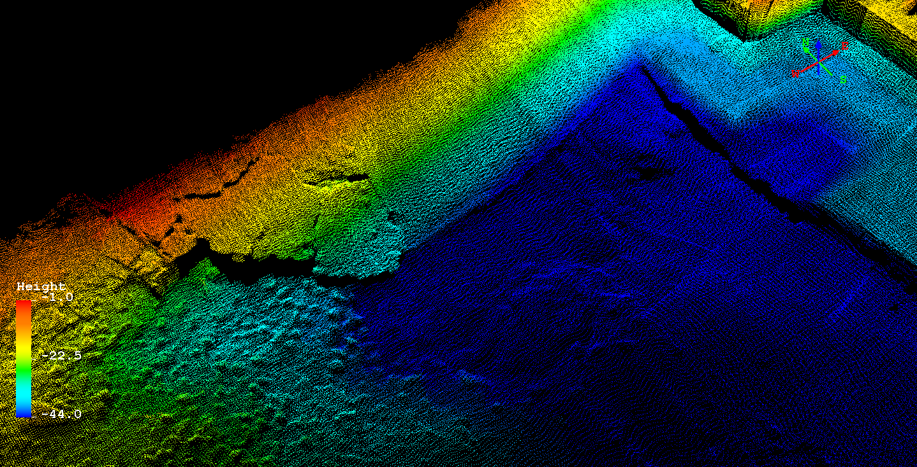
Cascades Island 2011.

